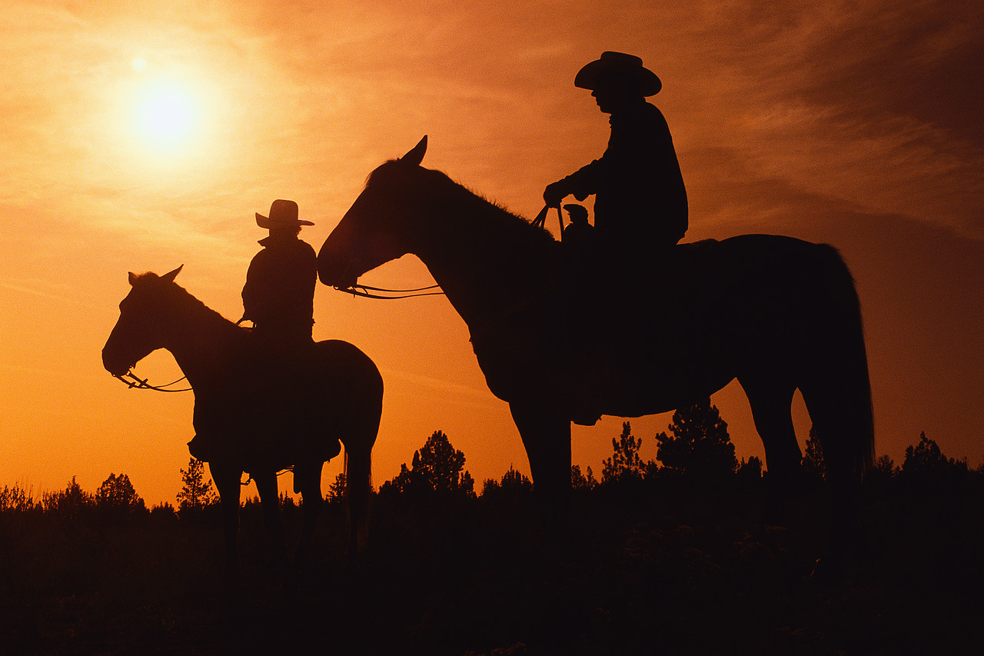

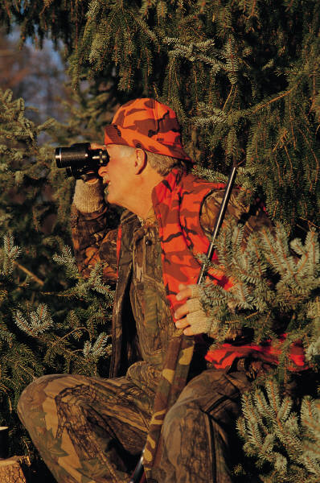
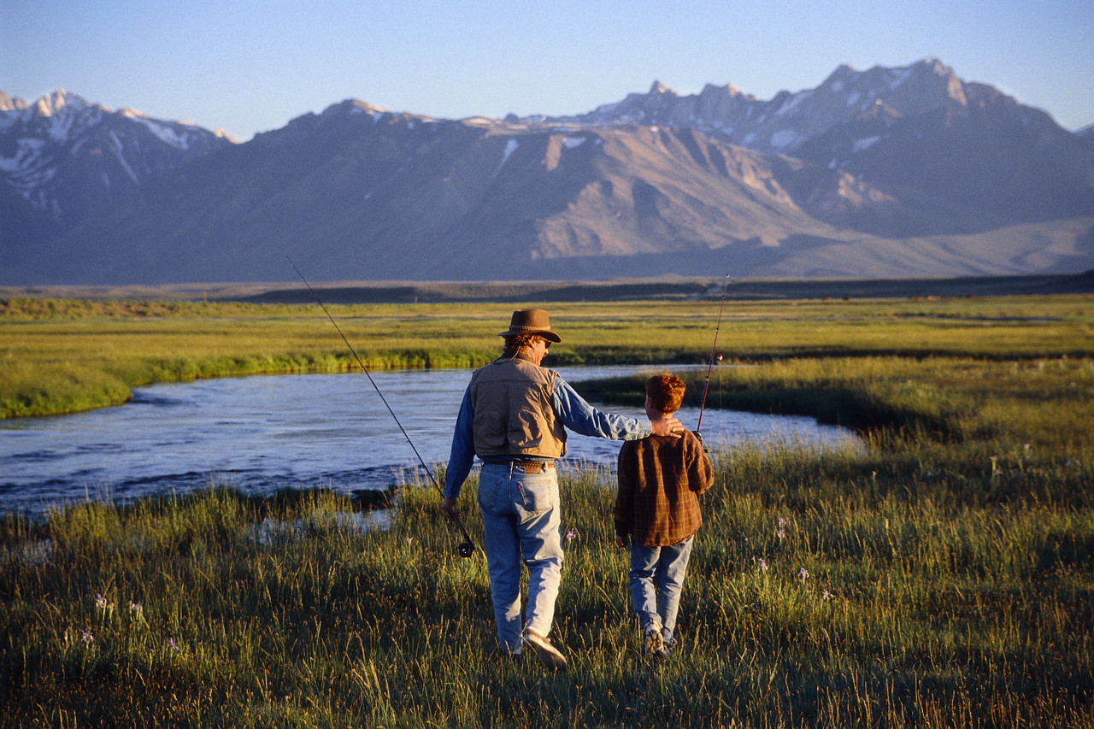
MEANWHILE, BACK AT THE RANCH

December 2014 Prepared by Louise Van Dyke
Board Meeting Schedule
December 20, January 17, February 21,
The meetings are the third Saturday of the month. Call the WHOA office to check to see if the meetings are still scheduled for the above dates or have been rescheduled.

Board Meeting Agenda Additions:
Any item that you would like to see on the agenda for the next Board Meeting should be submitted two weeks in advance of the Board Meeting date. You can submit them in writing by mail to 6700 Hwy. 36 West, Platina, Ca. 96076. or by fax to 530-352-4442, or email to the Board at rwhrdirectors@rwildhorseranch.net. Messages will go to every Board Member.

You can review the minutes of the Board Meetings on the Ranch’s web site at: www.rwildhorseranch.net in the owners only area.
TOP HAND (Ralph Hand--Ranch Manager)

Howdy, Pardners!

This has been a fast paced year here at the ranch, with lots of projects completed and more still in the working stage and on the drawing board for the days ahead. Your staff has been busy trying to stay ahead of the weather while moving forward with the approved repairs, replacements and retrofitting. Some of the outdoor projects have been put on hold thanks to the rain, but the indoor jobs are being handled in the meantime, including finally getting the Veterans’ wall moved. We’re looking to hear from some of the “pardners” who wanted to be involved with the design and placement of the pictures and will have plenty of room to add more.

Other projects that have been worked on include the snack bar paint and refurbishing, removal of the 45 year old 3 door reach-in at the upper lodge (it finally “died”) and replacement with a two door reach-in refrigerator and single door freezer; and removal and replacement of the walk-in down at the general store.

The work out at the lift station in the “C” area was completed just before the weather changed. Mother Nature cooperated on that one! We’re not complaining about any of the other projects. They are all far enough along that they won’t be hurt by the delay while all the storms blow through.

The weather has finally cooperated and the rain has been pouring—so much so that our pond is nearly up to street level and the fish and geese (they’re back!) are having a grand old time. The hills are all turning green (soon to be white, according to the weather reports), and there is no problem with dust right now. I think our prayers have been answered.

Thanksgiving was great with lots of good food, friendship and fantastic music thanks to the Petaluma Gang and their work to bring Train Wreck Junction to the ranch. The weather didn’t cooperate entirely, and we felt it prudent to avoid taking the horses down to Red Bluff for the night festivities and parade. A few of the “pardners” made it down to Redding for their parade on the following weekend and from what I have seen of the pictures, they had a blast.

We had an early delivery of some of the toys collected in Tom’s Annual Toy Drive. Word was passed down regarding a family facing a “last Christmas” with a loved one stricken with cancer. Theresa Paul from the rec center, and Mike Williams from maintenance, got things moving quickly to fill this need and the R-Ranch family’s early generosity helped make their wishes come true while the family could all be together. We’ll be delivering the rest of the toys and food items on the 20th, so there is still time to get gifts here for delivery. Please take a moment to reflect on how wonderful it is when this great ranch family pulls together. I know you all made my Christmas when the thanks came our way from this one family. I know you all made Tom’s, too. We know he’s still got his eye on us—just from a little further away.

Our bucket truck is here and should be ready to operate by the end of the month.

The PLM hunt went off at the end of November with John Brown showing off and getting a nice 5 x 6 buck. We’re not exactly thinning the herd, but it’s a start.

We’re keeping close tabs on our main well. We’re not using it right now while solutions are being tried and tested. So much of the infrastructure and mechanical parts here are hitting 40 plus years in age and were originally installed by the Wild Horse Mesa development. Our crew is doing a great job of staying on top of things and working through the challenges as they arise. Never a dull moment!

The New Year’s Eve Dinner/Dance and get together at the rec. center is coming up fast. Be sure to get your reservations in to Louise to enjoy the prime rib once again from R & R Meats (the best ever).
I want to wish all of you the best for the holiday season and coming New Year. We owners of R-Wild Horse Ranch are indeed blessed with all a vast mixture of backgrounds and beliefs and our common ground being our love of nature and the outdoors and the opportunity to realize and experience precious family moments and adventures. Our blending of our differences within our large ranch family is another valuable lesson we can pass to our loved ones. However you celebrate this time of the year, Christmas, Hanukkah, Omisoka, Kwanza, Bodhi Day, Eid-al-Adha, and any other celebrations that I’m apologizing if I missed, may you find joy and happiness for you and yours. Too bad the rest of the world can’t find a way to get along as well as we manage to here at the ranch.

To our owners who are currently deployed and serving in the military and also to those who have served before, you are heavy in my heart and I wish you all the peace and love I can offer. You are in our prayers.

I want to thank you all for the blessings you have brought to me and my family. You are all welcome to stop by and share some Christmas “cheer” at our place.

Sincerely, Ralph “Ranch” Hand

2014 Events at a glance.
All events with food are by RSVP due one week before event & An Event Fee may apply.

December
12/20/14 Board Meeting
12/25/14 Christmas Day
12/31/14 New Year’s Eve Prime Rib Dinner
Dance & Buffet
Music by The Montanes

2015
January
1/17 Board Meeting
1/18 Stables tack cleanup day

Bingo every Friday night if enough people
February
2/14 Crab Feed & Valentine Dance
2/15 Sweetheart Ride & brunch
2/15 Fishing Derby (if enough water in pond)

March
3/8 Daylight Saving time starts
3/14 St Patty’s Day dinner
3/15 Green Eggs & Ham Ride
3/21 ATV Ride

April
4/7 Mud Day & Golden Egg Ride
4/8 Easter Egg Hunt
4/18 Board Meeting
4/25 Annual Poker Ride

May

All events are subject to
change/cancellation

“OUR” R RANCH FIRE COMMTTEE REPORT

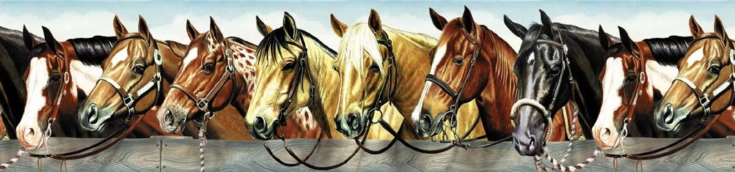
Company 6 R Wild Horse Ranch ~ 6700 Hiway 36 West ~ Platina, CA 96076 Company 6

R Wild Horse Ranch Fire Committee Report
December 2014

Next Fire Committee Meeting will be Dec. 20, 2014 @ 2 pm in the WHOA office.

R Wild Horse Ranch
EMERGENCY PROCEDURES for ALL OWNERS
The key to successfully handling any Emergency is to remain calm and know what to do! Report any fire or smoke immediately!
In the event of a personal emergency on the Ranch, there are yellow call boxes located at the gates, Upper Lodge, Recreation Center, the two cookhouses, several bath houses (when you arrive on the Ranch, check the closest bath house to you with a call box) and the Stables. Go to one of these call boxes; relate the nature of the emergency, location of the emergency and your name. If the Emergency is in the Outback or Horse Area, remain at the box to assist in directing Emergency Response Personnel to the location of the injured person(s).
If an Emergency involves the entire Ranch (such as a fire), evacuate to the Runway near the Pond Area. Do NOT bring trailers, or other bulky items! (Remember the trailer can be replaced – You can’t be!!) Ranch Staff have a plan to notify owners present on the Ranch of the Emergency and there is an Emergency siren as well. On the runway, do NOT block the left lane of any exit. These lanes need to remain clear for access by Emergency Vehicles. From the Runway, Owners will be directed on which route to take to evacuate the Ranch. If it is necessary to “shelter in place” (stay at the Pond), Owners will be directed on how this is to be accomplished.
It is imperative for your safety and the safety of others to remain calm, proceed in an orderly manner to the Runway and follow all directions given to you by Ranch Personnel.

Have a SAFE, wonderful, fun-filled stay here at R Wild Horse Ranch.

TOM MCMAHON MEMORIALTOY DRIVE

TOM MCMAHON MEMORIAL FILL THE
HORSE TRAILER TOY DRIVE
IT’S TIME TO START OUR TOYS/GIFTS DRIVE FOR THE KIDS!!!!

You can donate toys /gifts or cash if you don’t have time to shop. We have connections to wholesalers to get toys at a discount. We will fill the horse trailer with your help. We should have it full by Christmas. You can drop off the donations to Charli Hand at her office by the General Store or to Theresa at the Rec. Center. Every donation will be greatly appreciated.
For every $10 toy you donate we will give you 1 daily guest pass.

A GREAT BIG THANK YOU TO ALL OF YOU WHO DONATED TOYS AND CASH FOR TOM’S TOY DRIVE. IT HAS MADE A GREAT CHRISTMAS FOR MANY KIDS.





New at the Store






STRAIGHT FROM THE HORSE’S MOUTH (Stables)
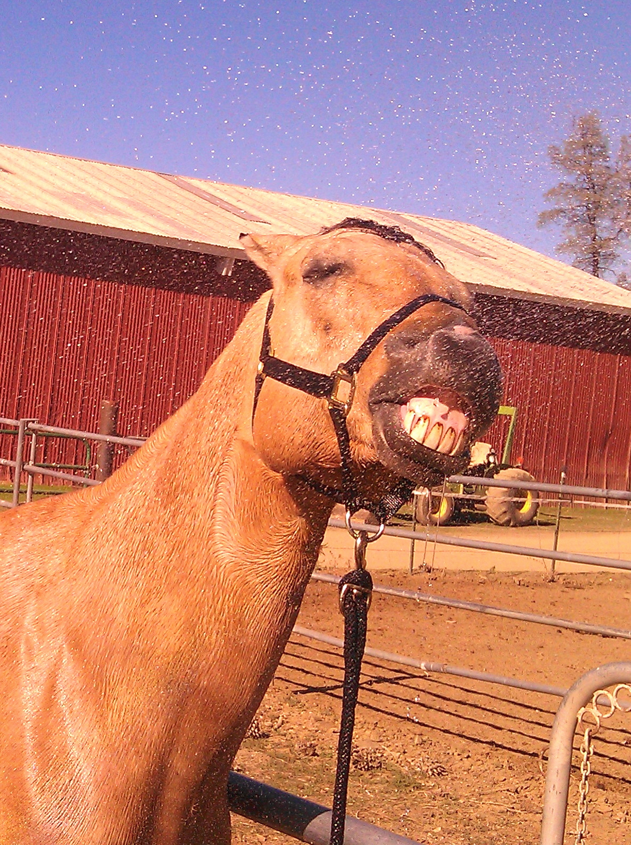
Howdy All!

We here at the stables really appreciate all you owners who are bringing your owners card down to ride. Please have your owners and associate cards with you to ride.

The trails are closed due to the rainy weather making the trails muddy and slick. Our goal at the stables is to keep owners and horses safe. The arena is open for your convenience.

Thank you and see you at the Stables.

Happy Trails,
The Barn Staff
NOTE:
All PHI Mercy Air Members

WARNING:

This ambulance plan is not an insurance program. It will not compensate or reimburse another ambulance company that provides emergency transportation to you or your family. This may occur when the 911 emergency system has independently determined that another company could provide more expeditious service or is next in the rotation to receive a call. This might also occur when this ambulance plan is unable to perform within a medically appropriate timeframe due to a mechanical or maintenance problem or on another call. Other air ambulance you could contact for additional coverage:

Reach For Life Enloe Flight Care of Chico
707-324-2422 800-822-8102
866-767-3224 530-322-6774

For membership applications you can call them and ask f0r one to be sent to you or go online and print one out. The membership prices are on the application.
For a PHI membership application contact Stephanie in the WHOA office at 530-352-4222 and she will sent you one.

R Wild Horse Jewelry

Large Silver Pendant $105.00*
Includes sales tax

Small Silver Ear Rings $175.00*
Includes sales tax

Large Gold Pendant $ Call Stephanie for Price *
Includes sales tax

Small Gold Ear Rings $ Call office for Price*
Includes sales tax

*Special orders only, must be paid for at time of order.

530-352-4222 ext. 409 or email: Stephanie at smcreynolds@rwildhorseranch.net

*prices subject to change

FROM THE WHOA OFFICE

The 2015 Assessment invoice, Budget, Assessment Collection Policy and a few other pieces of information have been mailed. If you do not receive your “packet” by November 20th, please call the office. If your address has changed, please call and we will update your account. There’s still time to make payments towards the 2015 assessments. If you would like to do this, feel free to call us. It will make your January 1st payment a little smaller. REMEMBER, the assessments are DUE IN FULL January 1st and become delinquent January 16th.
New this year: you can pay your assessments on the R-Wild Horse Ranch website. Simple visit the website and provide the requested information.
Thanks to all of you for your assessment payments. You are the reason the Ranch continues to succeed!
Feel free to contact Stephanie or Kathy if you have questions. We are available Tuesday-Saturday 7:00AM-4:00PM. Our phone number is 530-352-4222.
A WATCHFUL EYE (Security)

From Security
Howdy partners,
ATV’s, side by sides, motorcycles and any other off road vehicles, please enjoy the riding area. When you are out back there are rules to follow:
- You must stay on the roads
- Speed limit is 10 miles per hour
- You must be with your guest at all times when in the riding area and out back.

Security is patrolling out back at any time and will be issuing ranch violations. If you see a trail/road made by someone else that is clearly not a main road out back please stay off of it. Owners you are responsible for your guests and their actions. Please help us save “R” outback from people misusing it.

Thank You
Security
Dale, Jim, Bob F, and James

To All Owners:
RE: Wrist Bands for Guests

At a recent board meeting, there was extensive discussion about the trial we just completed regarding the use of wrist bands. Based on the results of this trial, the Board adopts the following policy regarding wrist bands.

Wrist bands will be worn by all guests at all times they are present on the ranch.

At the present time, owners will not be required to wear a wrist band. Owners should carry their ID cards as required by the By-Laws (Article IV, Section 3) and in the Information Book of Rules for the R Wild Horse Ranch Owner’s Association (WHOA) and present it when asked to do so by a Ranch employee. Owners not having an owner’s ID card in hand will not be allowed to participate in an activity (i.e.: riding a ranch horse) until such time as they can provide proper identification. Owners repeatedly warned about not carrying their card on their person may be fined as determined by the Ranch Manager. A request for further disciplinary action would be presented to the Board of Directors.

Adopted July 25, 2014
__________________________________
Ralph Hand, Manager
RWHR Guest Services

R RANCH DIRECTORY

General Store 530-352-4448
Open 7 Days a Week
Mon-Sun 9am to 5pm
*Hrs subject to change

Ralph Hand, Owner Relations Manager
rhand@rwildhorseranch.net

Jonathan Barrett, Operations Manager
Jbarrett@rwildhorseranch.net

Stephanie McReynolds, Ranch Secretary/collections Ext. 409
smcreynolds@rwildhorseranch.net

Security 530-352-4486
security@rwildhorseranch.net

ownerservices@rwildhorseranch.net

Stables 530-352-4499
stables@rwildhorseranch.net
(Winter Hours) 7am to 4pm Riding 7am to 3pm
(Summer Hours) 6am to 3pm Riding 6:30am to 2 pm
- Hrs subject to change

Maintenance 530-352-4444
maintenancedepartment@rwildhorseranch.net

Rec. Center 530-352-4456
reccenter@rwildhorseranch.net
Office Friday---Monday. 9am to 6pm
*Holidays-- Hours Subject to Change

WHOA Office 530-352-4222
Fax 530-352-4442
Closed Sunday
Mon – Sat 7am to 4 pm
R Wild Horse Ranch: ranchwild@rwildhorseranch.net

WHOA Assessments & Collections 530-352-4222
Kathy Ext. 403
kbowers@rwildhorseranch.net

Reservations 530-352-4222 Ext. 402
reservationslv@rwildhorseranch.net

Event Info: www.rwildhorseranch.com
Email: events@rwildhorseranch.net

Swimming Pool Area : 9 am to 10 pm No glass bottles/containers

Hot Tub: 9 am to Midnight No glass bottles/containers/food

No one under 16 in Hot Tub

BOARD OF DIRECTORS

Your Board of Directors:
President: Alice Forbes
1st Vice President: Ed Marion
2nd Vice President: Jim Barbour
Treasurer: Ron Clark
Secretary: Mary Halbasch
Email your board of Directors: rwhrdirectors@rwildhorseranch.net email will go to every Board Member.
Want to run for the Board of Directors
Election for the 2015—2017 term for the Board of Directors will be held at the Annual Owners Meeting and Election in Aug. 2015. There will be three seats up for election



R-Wild Horse Ranch Owners Association Board of Directors
6700 Highway 36 West, Platina, CA 96076
Office (530) 352.4222 or Fax (530) 352- 4442

December 1, 2014
Happy Holidays to All Owners:

What a rainy period we are having at the Ranch! Not complaining because we really need the rain! The rain enabled Ralph to allow campfires again and I know many have been enjoying that! The holidays are a time for reflection and giving Thanks. Thanksgiving was a big success for all the owners- especially those with reservations! We are renaming the wristband we used for those with reservations to ‘FIRST IN LINE” bands! There were many who were early but had not apparently made a reservation and they went to the end of the line. This is the new way we are going to do this for events in the future. Owners with reservations will eat first, then those without reservations got to eat. This is an effort to insure that we do not buy too much food and waste it, so please make your reservations for future events. We did end up having enough of the turkey and stuffing – but I know that many of the side dishes and salads were gone by the time folks with no reservations got to eat,

News around the ranch: The cooler in the store went out and will be replaced out of the reserve Funds. The playground equipment was selected and the check has been sent so we hope to see the structure soon. Jonathan did a lot of research and found a $56k structure for $28K and it is magnificent and should last for many, many years as it is a commercial grade structure. I know many of us are looking forward to it!

We have made the first installment on the new employee homes and they should begin arriving mid-January. Ralph and Jon are working to get the old ones gone. The housing will hit the Reserve Fund hard, but there is a spreadsheet showing we should be back to $900k to a Million by January, 2016 depending on past collections as well as barring any new emergencies!! We were faced with issues with the Café and Upper Lodge kitchen and decided not to “band aid” it one more time. It is unfortunate, but most of the Ranch equipment is 35+ years old and it will breakdown, but thanks to the vigilance of Jim Bowers, Randy Apoian and Ron Clark, previous Board Members, building and maintaining the Reserve Fund, we are now in pretty good shape to be able to make repairs!

The other key decision made by the Board recently was to award a Grazing Lease. Mary is working to repair the fences and will be bringing cattle on-site once this is completed. If you are out on ATV, motorcycles, etc., please be aware that there are now cattle grazing in the area. According to the lease, any incident between a cow and an owner will be dealt with between the leasee and the owner – the Ranch will not be involved. So it is in your interest to be careful and follow all the rules in the outback, including speed limits. Also in light of the rain, we have been having, the roads are really slippery and muddy. Please stay on the roads and only mud bog or whatever in the designated ATV area. This is OUR RANCH and as owners, we are all responsible for maintaining it in good condition and this includes the outback area. We do not want excessive erosion and environmental damage to occur anywhere on the Ranch. We can avoid this if we, as OWNERS, take care of it!

The new Café has been busy and a success from all the comments I have heard! It has a great menu and Brooke and Oni are very interested in the Ranch and making a success of the Café for all of us.

As always we are here to serve all owners, so if you have a concern please do not hesitate to contact us either through the WHOA Office or email. Hope to see you all at the Ranch!!

Sincerely,
Alice R. Forbes, President
RWHR Board of Directors

2015 PLM HUNT

RAFFLE drawing to be held July 4th 2015

All winners of the R-Wild Horse Ranch PLM late season deer hunt to be held November 17, 18 and 19, 2015 must be an owner in good standing (assessments must be current) of the R-Wild Horse Ranch at the time of the hunt. Winners must have a current California hunting license and “B” zone deer tag.

The “B” zone deer tag must be exchanged for the PLM tag. This is a requirement of the Department of Fish and Game so that no hunter can harvest more than two (2) deer in the State of California.

All PLM tag winners will be allowed one (1) person to accompany them on their hunt to help them spot game and retrieve harvested animals. The accompanying person is NOT allowed to carry or possess a firearm while in the PLM hunting area.

PLM winners and their companions with vehicles, ATV’s, 4x4’s, motorcycles, etc, must stay on roads.

Property boundaries will be marked by fences, blue paint markings, blue ribbon or signage. Maps will be available to tag winners.

Recipients of the PLM deer tag will also be able to hunt bear and wild pig, provided they have valid bear and pig tags.

This deer hunt is a three (3) point or better hunt; meaning the deer must have at least three (3) points on one (1) side NOT INCLUDING EYE GUARD-BROW TINE. Bear and pigs must be hunted according to State of California Fish and Game regulations and laws.
All animals harvested MUST be brought to the main gate for validation and record keeping for the PLM program. This is a requirement of the Department of Fish and Game. Also, this is an opportunity for photos for the R-Wild Horse Ranch Newsletter to help promote next years PLM hunt.

This is a three (3) day hunt only and the dates will change yearly as scheduled. The 2015 hunt will be held Tuesday, Wednesday and Thursday November 17, 18 and 19, 2015.

There will be an orientation dinner at 7:00PM Monday evening November 16, 2015 at the upper lodge of the R-Wild Horse Ranch for tag winners and the person accompanying them.

If you have questions about the hunt or where to purchase your raffle tickets, please contact:

Ralph Hand 530-352-4222 or John Brown 530-352-4444

NOTE: Anyone caught in violation of PLM rules or Fish and Game laws will forfeit their tag and will be asked to leave. Fish and Game will also be notified.

PLM HUNT Raffle tickets are $100.00 per ticket. There are only 100 tickets. To insure your chance at being drawn for the hunt get your ticket early. You can purchase a ticket at the WHOA office and the Store or you can call the office and pay with a credit card over the phone.
Part of the money from the sale of the tickets goes to the Ranch for wild life habitat improvement.

PLM Hunt Raffle tickets make great gifts!!!!!!

NEW YEAR’S PRIME RIB DINNER
BY RESERVATION ONLY

DINNER WILL BE SERVED 6PM TO 8PM
AT THE ADULT LODGE

DINNER WILL INCLUDE:

Classic Caesar salad
Roast PRIME RIB au jus
Loaded mashed potatoes
Southern style green beans
Rolls and whipped butter
Nanny’s bread pudding with bourbon sauce
byob

MUST RESERVE BY DECEMBER 26TH
ADULTS ONLY---$30.00 PER PERSON

Make check payable to WHOA (Can pay with credit card over the phone by calling WHOA at 530-352-4222)
R Wild Horse Ranch 6700 Hwy 36 W Platina Ca 96076
Please cut on line and return bottom portion with check to WHOA office at above address

NEW YEAR’S EVE PRIME DINNER RESERVATION

NAME___________________________________________

OWNER NUMBER__________________________________

NUMBER IN PARTY____________& NAME OF THOSE IN YOUR PARTY

----------------------------------------------------------------------------------------

---------------------------------------------------------------------------------------

AMOUNT ENCLOSED________________________

MUST BE RECEIVED BY WHOA OFFICE NO LATER THAN DECEMBER 26TH.

New Year's Eve

December 31, 2014

Happy New Year!!!

Happy New Year!!!

R WILD HORSE OWNERS ASSOCIATION
R Ranch Guest Fees
REVISED GUEST FEES EFFECTIVE JANUARY 1, 2015


*GUEST FEE PER DAY $15.00
2 HOURS OF ANY DAY IS CONSIDERED A DAY.
No charge for children under the age of 6.

Cabins Per night *guests $25.00
Owner w/rv on site $15.00

Motels per night owner $20.00
Guests $40.00

Rv site-DRY CAMPING Guest $15.00

*Horseback riding arena $10.00
Under age 6 no charge Trail $20.00
(Owner must have trail card)

Guest atv/motorcycle/golf cart $5.00
Dual passenger off road vehicle
Per day per vehicle
Fee must be paid prior to entering ranch

PLACARD $10.00
PLACARD WITH OWNERS NUMBER
ONE TIME FEE FOR EACH OF ABOVE VEHICLES
EACH GUEST WITH ABOVE VEHICLES MUST HAVE PLACARD
WITH THE OWNER’S NUMBERS ON EACH ONE.

Kitchen rental per day - OWNERS $75.00
Non-refundable – Owners and guests are
Reminded, that only the kitchen may be reserved.
The upper lodge is open to all owners and guests. Children are only allowed in the upper lodge for Meals. The upper lodge/motel area is an adults only Area.

BUNKHOUSE (MOBILE) RENTAL: PER DAY $100.00
2 NIGHTS MINIMUM PLUS $100 REFUNDABLE CLEANING FEE
(Refundable, AFTER INSPECTION AND INVENTORY.)

*guests under 18 must have A signed release From parents with them at time of Arrival to ranch

R Wild Horse Ranch
Owners & Guests

Dogs must be on a
leash at all times

No dogs allowed in pond

